NAAN MUDHALVAN ASSIGNMENT DOCUMENT

**COURSE TITLE** : DIGITAL MARKETING

**COLLEGE CODE** 1105

**COLLEGE NAME** : GOJAN SCHOOL OF BUSINESS AND TECHNOLOGY

**NM ID** : 6B6591BA0E472F79EE44706C0F12E100

**NAME** : SURESH KUMAR C H

**REGISTER NUMBER** 110520106337

**YEAR** : 4TH YEAR

**DEPARTMENT** : ELECTRONICS AND COMMUNICATION ENGINEERING

1. Create a blog or website using Blogspot and Wordpress. Customize the theme design and post new article with 500 words.

Link <https://giftphile.blogspot.com/2023/10/gift-phile.html>



1. Create a New Facebook Business Page and post one social media poster for your brand.

Link: [https://www.facebook.com/people/Gift-](https://www.facebook.com/people/Gift-Phile/pfbid02CampMTU53KBRbkkMHDUQxaZfUW2b4Kkb2jBEiqwjMQFaoNrKB9vSf1GancQ1v4J6l/?mibextid=ZbWKwL) [Phile/pfbid02CampMTU53KBRbkkMHDUQxaZfUW2b4Kkb2jBEiqwjMQFaoNrKB9vSf1G](https://www.facebook.com/people/Gift-Phile/pfbid02CampMTU53KBRbkkMHDUQxaZfUW2b4Kkb2jBEiqwjMQFaoNrKB9vSf1GancQ1v4J6l/?mibextid=ZbWKwL) [ancQ1v4J6l/?mibextid=ZbWKwL](https://www.facebook.com/people/Gift-Phile/pfbid02CampMTU53KBRbkkMHDUQxaZfUW2b4Kkb2jBEiqwjMQFaoNrKB9vSf1GancQ1v4J6l/?mibextid=ZbWKwL)

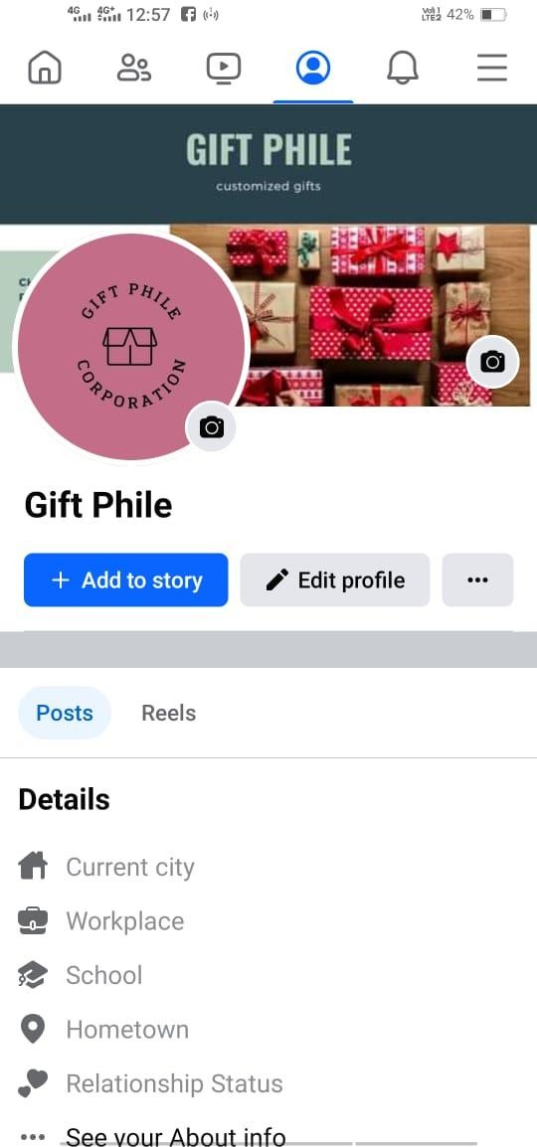

Create and design a social media advertisement poster using canva.

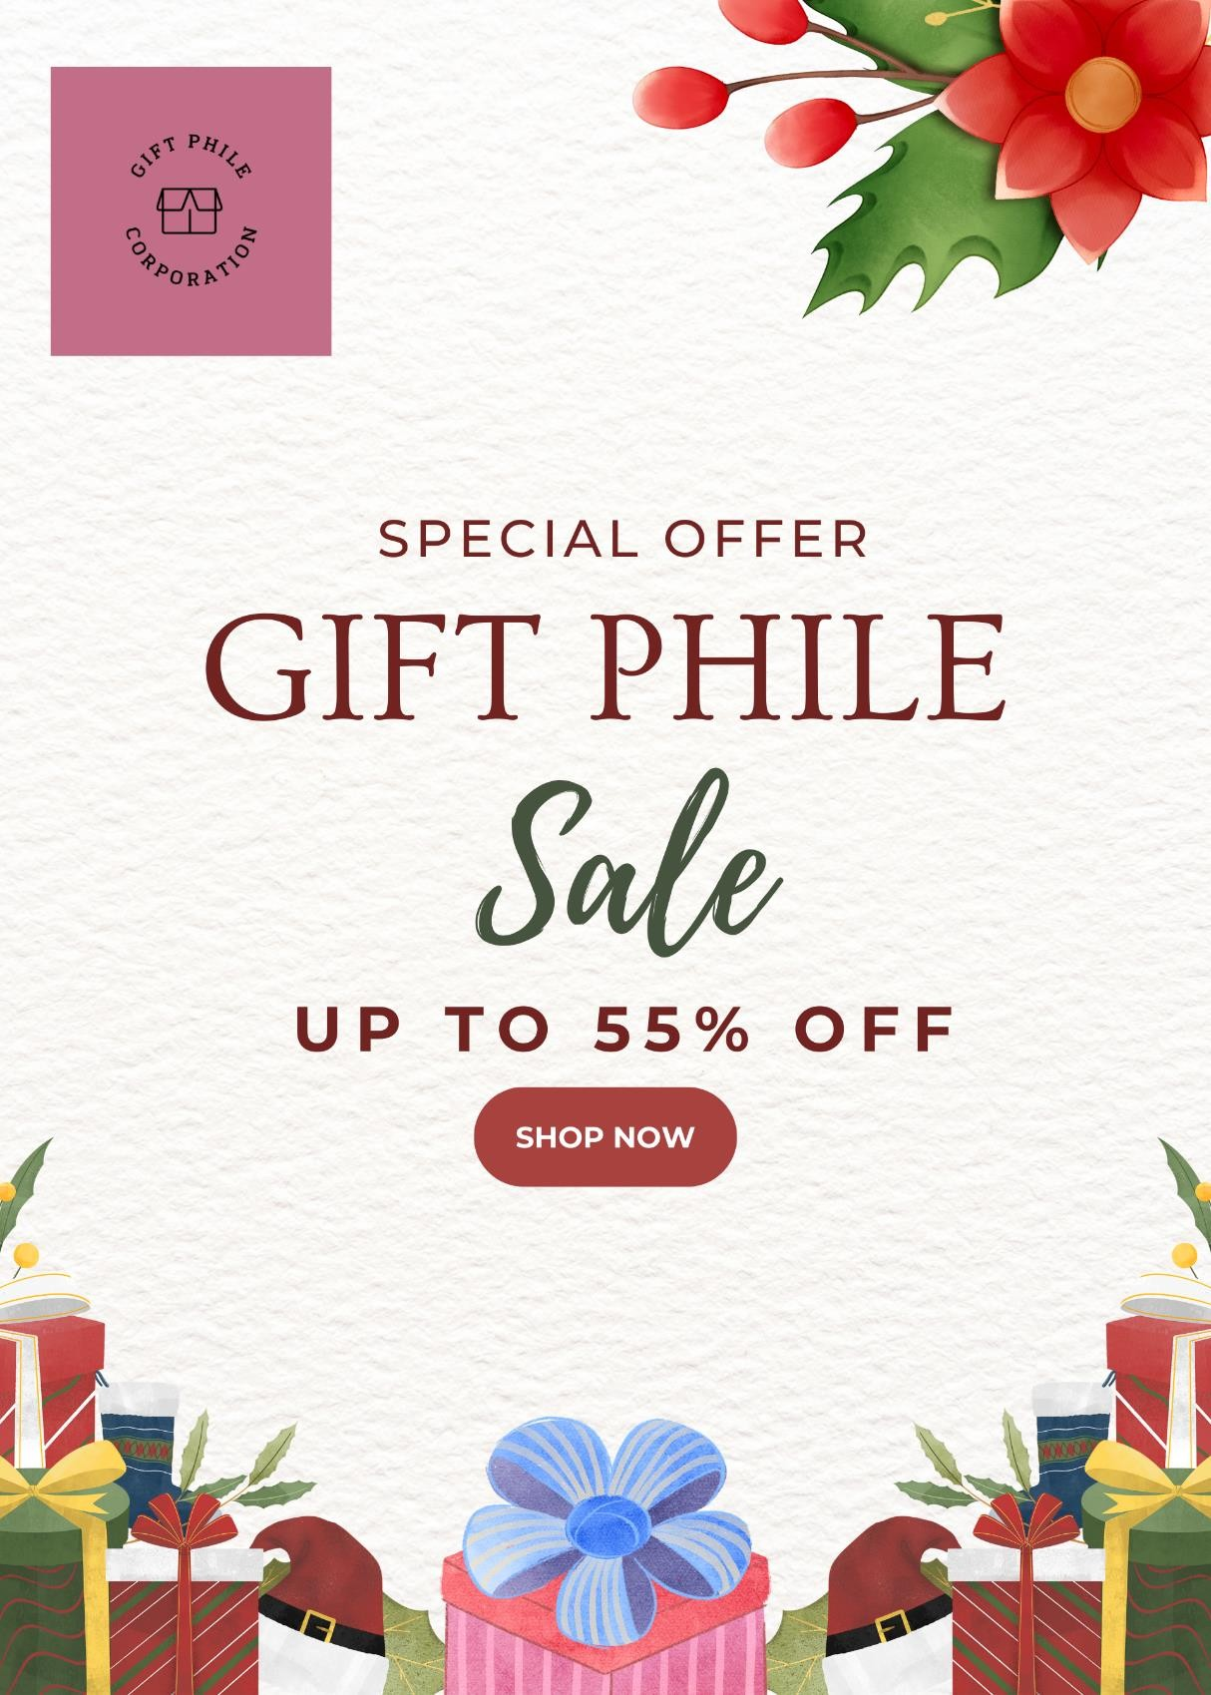

1. Create email newsletter design using MailChimp or canva tool.

Link: [https://www.canva.com/design/DAFx9hW-](https://www.canva.com/design/DAFx9hW-rcQ/CVfJ0yUQ4E7PHVMePdWF2w/view?utm_content=DAFx9hW-rcQ&utm_campaign=designshare&utm_medium=link&utm_source=editor) [rcQ/CVfJ0yUQ4E7PHVMePdWF2w/view?utm_content=DAFx9hW-](https://www.canva.com/design/DAFx9hW-rcQ/CVfJ0yUQ4E7PHVMePdWF2w/view?utm_content=DAFx9hW-rcQ&utm_campaign=designshare&utm_medium=link&utm_source=editor) [rcQ&utm_campaign=designshare&utm_medium=link&utm_source=editor](https://www.canva.com/design/DAFx9hW-rcQ/CVfJ0yUQ4E7PHVMePdWF2w/view?utm_content=DAFx9hW-rcQ&utm_campaign=designshare&utm_medium=link&utm_source=editor)

